 ***U****NIVERSITY OF RWANDA*

*HUYE CAMPUS*

*COLLEGE OF BUSINESS AND ECONOMICS*

*BUSINESS INFORMATION AND TECHNOLOGY*

*ACADEMIC YEAR: 2022-2023*

*NAMES: Twiringiyimana Eric*

*REG: 221008062*

*Project name: Hostel Management System*

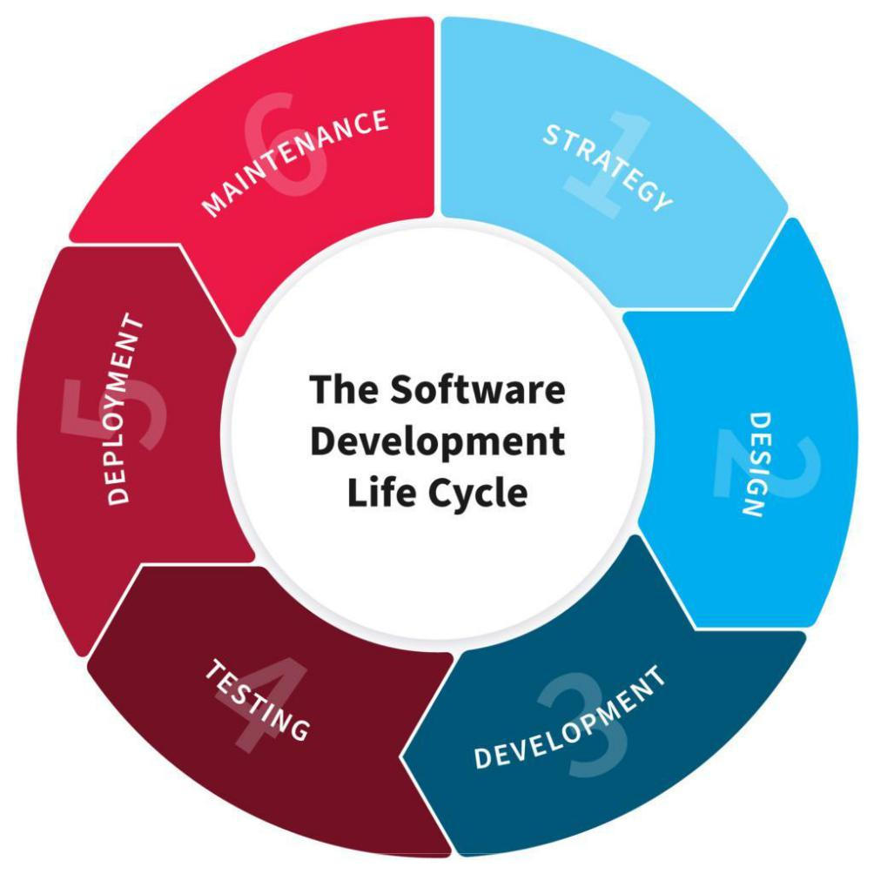

***HOSTEL MANAGEMENT INFORMATION SYSTEM***

*Software application which designed to manage all hostel activities like hostel information, room allotment, payment and generates related reports for smooth transactions*

*This was submitted with one module given below*

***1). Login Option:***

*If the user already contains an account in this system, this form permits to enter in to this Hotel Management system. Now he can use all the facilities provided by this Mailing System.*

***User Menu:*** *Provides a way to give any commands to the Hostel Management System*

*the options include in the menu are*

*1. Student*

*2. Fee Details*

*3. Room Allotment*

*4. Attendance*

*5. Refunds*

*6. Exit*

***1. Student:*** *This screen having option to enter entire details of student and have an option to save the Details. The fields in this screen are:*

***Studen ID:*** *It is Uniquely identified by the each student*

***Stuname:*** *Student Name.*

***Age:*** *Age of the Student .*

***Address :*** *Address of the student*

***Mobile:*** *Mobile number of the student*

***2). Fee:*** *If the user selects this option on the user menu the corresponding Fee details of the user will be displayed. To read the different fields, one option is provided as a save by clicking on the save button.*

***3) Attendance:*** *Using these options the user can selects Attendance option , different student id’s will be available , if u want a particular student id select one of them from the drop down list and enter corresponding details , finally save it by clicking save button.*

***4) Room Allotment:*** *By clicking this option one more screen will be displayed on the screen is Room Allotment screen. This screen can be used to add new details to the database system. Here various listings of room with the room number and there floor name. Here we have various options.*

***Save:*** *User to save the details of the student.*

***Modify:*** *This option is used to update any student room allotment information.*

***5) Refund:*** *By selecting options menu one more screen will be displayed, the screen is Refund amount Screen. This form will contains all information about balance amount, amount payee by the student and also fine details for a particular student. It contains following providers*

***Save:*** *User to save the details of the student.*

***Objectives of Hostel management information system:***

*To manage the details of Rent, Hostel, Rooms, Payments. It manages all the information about Rent, Beds, Payments, and Rent. The project is totally built at administrative end and the Users only the administrator and users are guaranteed full the access.*

***The problems that the Student Management System project aims to solve include:***

*Using analog system for storing information*

*Damaged/loss of stored data and lack of updating*

*Data entry errors and inaccuracies in hostel information system*

*Inefficiency in the current manual system for managing hostels records.*

***Design Phases***

***Technical Requirements***

* *The system was developed as a java application using Apache net Beans IDE.*
* *The system use MySQL Workbench as the database management system to store and manage student data.*

***Functional Requirements:***

* *The system will provide a centralized platform for administrators to access and manage student data.*
* *The system will allow for the input, storage, and retrieval of student information, including personal information, enrollment records, and grades.*
* *The system will include a reporting feature that allows for monitoring student data for academic improvement.*
* *The system will include security measures to ensure the confidentiality and security of student data for example a login feature to authenticate the admins.*

***User Interaction***

*The administrator will have access to all student records and will be able to input and manage student data like personal and grades information, generate reports, and export student information as pdf fles.*

* *Users will interact with the system through an interface that is easy to navigate and user-friendly.*

*The system will have validation and error handling in place to ensure data integrity and to guide the user through the process*

***Overall System Design Structure***

Login

Student Information

Fee Details

Room Allotment

Attendance

Reports

Student Info

New

Modify

Delete

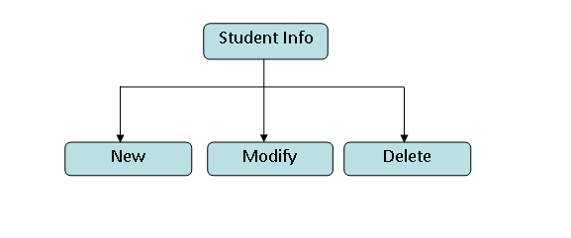

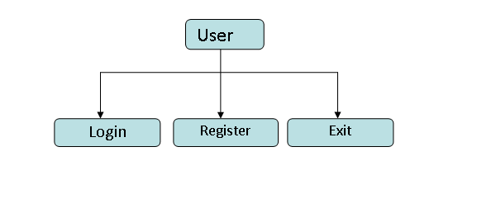

Student Info

New

Modify

Delete

***Development Phases***

*Development steps for the Hostel Management Information System project in Java using Apache Net Beans IDE and MySQL database:*

***Database design and setup:***

*We used MySQL as the database management system \DBMS\.*

* *Creating database schemas and data models that align with the system's functional requirements \admin, student, courses, and score schemas\.*
* *Connecting to MySQL using “mysql-connector-java-8.0.26” driver.*
* *Creating the admin, student, courses, and score tables and felds in the database using SQL scripts.*
* *Defining relationships between tables.*

***Project development:***

* *Open A*
* *Apache Net Beans IDE and create a new Java project for the student management system.*
* *Develop the interface of the system using Java Swing.*
* *Develop the system and implement the necessary methods to handle the insertion of information, data manipulation and validation.*
* *Handling the communication between the application and the database.*
* *Implementing a login system to ensure the confidentiality and security of student data.*
* *Ensure data is being stored, retrieved, and manipulated correctly.*

***Testing Phases***

*Testing Plan for the Hostel management Information System project:*

* *Testing if the components of the system, such as the database and the user interface works correctly.*
* *Develop integration tests for the entire system to ensure that all the components are working together correctly.*
* *Testing the system as a whole to ensure that it is meeting the functional and technical requirement*

***Deployment Phases***

*Installation, testing, and performance monitoring of the Student Management System on the local computer can be conducted as follows*

***Installation:***

* *Download and install the necessary software, such as the Apache Net Beans IDE, MySQL and the Java Development Kit \JDK\ if it is not yet installed on the local computer.*
* *Clone or download the project to your local machine from git hub.*
* *Download and configure the necessary settings for the system, such as setting up MySQL Workbench and MySQL-java-connector driver.*
* *Open the project in the Apache Net Beans IDE and build the project to ensure that all dependencies are properly installed.*
* *Run the system on the local computer to ensure that it is working as expected.*

***Maintenance Phases***

* *Regularly conduct tests on the system to ensure that it does not break and is still working as expected.*
* *Provide user support and troubleshoot any issues that arise.*
* *Collect feedback from users and use it to make improvements to the system.*

*Continuously*

***CONCLUSION***

*The project titled as "****Hostel Management Information System” been*** *designed with much care, with the intention easier and the more complexity involved is presented in a simple and lucid style.*

*The Hostel Management System works in a similar fashion as that of an Hotel Management System. The various Department student information is to be stored and retrieve any time when required.*